NAMES:
MUHAMMAD FAHEEM (42346)
RIZWAN ZAHID (38386)
DANIYAL HUSSAIN (38233)
MUHAMMAD BILAL (37177)
MARYAM MAJID (38236)
AYMEL MOEEN (38252)
COURSE:
WEB ENGINEERING
INST NAME:
SIR FAHEEM SHOUKAT
PROJECT TITLE :
SwiftCare -We take care of Your health
Your appointment on a Click!
Link: https://swift-care.xo.je/

REPORT
- Introduction:
Project Overview
SwiftCare is a web-based healthcare appointment management system developed using PHP and MySQL. The system provides an online platform that allows patients to book medical appointments easily, while administrators can manage doctors, schedules, and appointment records efficiently. The project is designed to replace manual appointment booking methods with a fast, reliable, and automated digital solution.
The system follows a structured approach where users interact through web forms, PHP processes the logic, and MySQL stores and retrieves data. SwiftCare ensures better record management, improved efficiency, and enhanced user convenience.
- Problem Statement:
Many healthcare institutions still rely on manual or semi-manual systems for appointment booking. These systems often cause long waiting times, scheduling conflicts, data loss, and poor record management. Patients face inconvenience, while administrators struggle to manage appointments and patient information accurately.
There is a need for a centralized web-based system that can automate appointment scheduling, reduce human errors, and provide secure data storage. SwiftCare aims to solve these problems by offering an online appointment booking and management system.
- Objectives
The main objectives of the SwiftCare project are:
- To develop an online healthcare appointment booking system
- To implement CRUD operations (Create, Read, Update, Delete) using PHP
- To manage healthcare data efficiently using MySQL
- To provide role-based access for different users
- To reduce manual workload and improve accuracy
- To apply Web Engineering concepts in a real-world project

- Technology Stack
PHP:
PHP is used as the server-side scripting language. It handles application logic such as form submission, user authentication, session handling, and CRUD operations. PHP files process user requests and interact with the database using SQL queries.
Database (MySQL / SQL)
MySQL is used to store system data such as users, doctors, appointments, and schedules. SQL queries are used for inserting, retrieving, updating, and deleting records. The database ensures structured data storage and data integrity.
WordPress
WordPress is not used in this project. SwiftCare is developed entirely using custom PHP and MySQL without any content management system.
Hosting Platform
The project is developed and tested on a local server using XAMPP, which includes Apache and MySQL. The system can be deployed on any PHP-supported hosting platform if required.
- System Features
Description of CRUD Functionalities
SwiftCare implements full CRUD functionality:
- Create:
Patients can register and book appointments. Admin can add doctors and schedules.
- Read:
Admin and doctors can view appointments, patient details, and schedules.
- Update:
Appointment details, schedules, and user information can be edited.
- Delete:
Admin can delete appointments, doctor records, or outdated data.
These operations are implemented using PHP scripts connected to the MySQL database.
User Roles
- Admin: Manages doctors, schedules, appointments, and system data
- Doctor: Views assigned appointments and schedules
- Patient: Registers, logs in, and books appointments
- Database Design:
ER Diagram
The ER Diagram represents relationships between users, doctors, appointments, and schedules. It shows how appointments are linked to patients and doctors through unique IDs. This design helps maintain data consistency and avoids redundancy.
Tables Description
Users Table
- user_id (Primary Key)
- name
- email
- password
- role
Doctors Table
- doctor_id (Primary Key)
- name
- specialization
- availability
Appointments Table
- appointment_id (Primary Key)
- user_id (Foreign Key)
- doctor_id (Foreign Key)
- appointment_date
- appointment_time
Schedules Table
- schedule_id (Primary Key)
- doctor_id (Foreign Key)
- session_time
- System Implementation
PHP Logic Explanation
The system is implemented using modular PHP files. Database connection is handled through a separate configuration file. Authentication and authorization are managed using PHP sessions. Each CRUD operation is handled through structured PHP scripts that interact with the database securely.
CRUD Operation Flow
- User submits data through a web form
- PHP validates the input
- SQL query is executed (INSERT, SELECT, UPDATE, DELETE)
- Database processes the request
- Output is displayed on the web page
WordPress Customization
Not applicable, as WordPress is not used.
7. Screenshots
The following screenshots should be included in the final report:
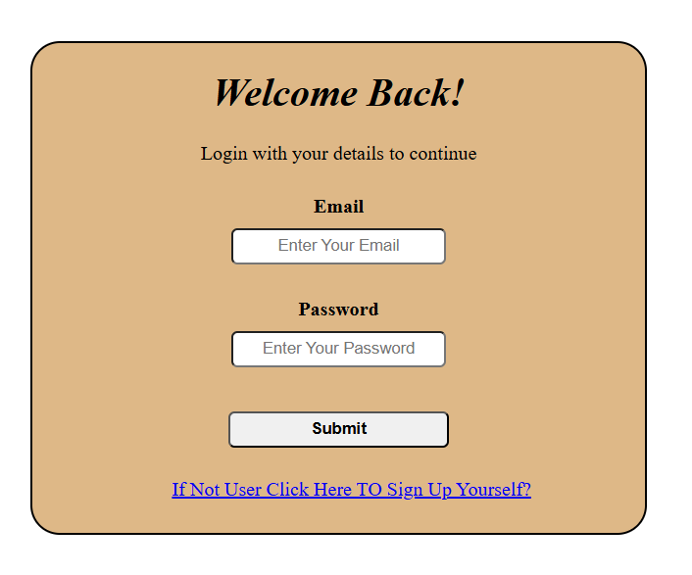
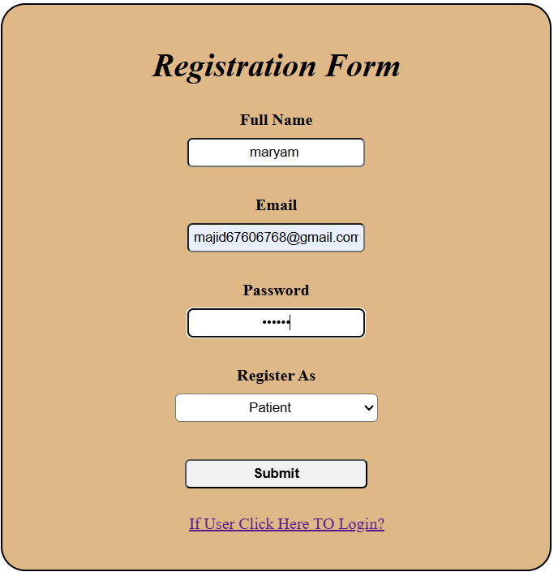
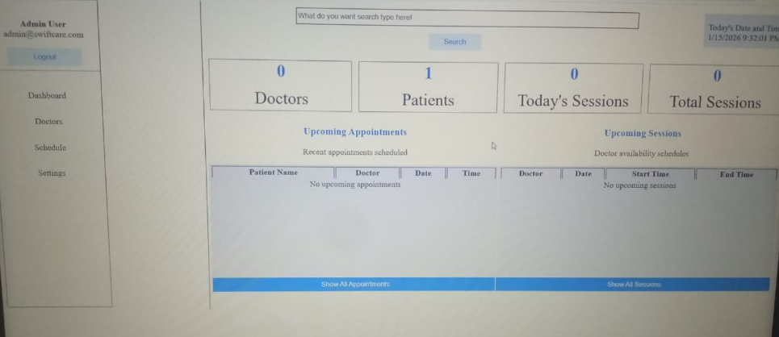
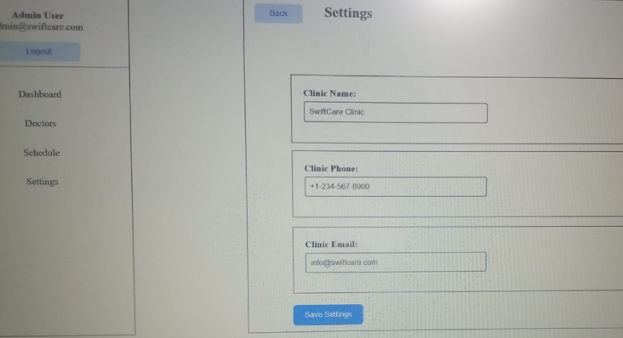
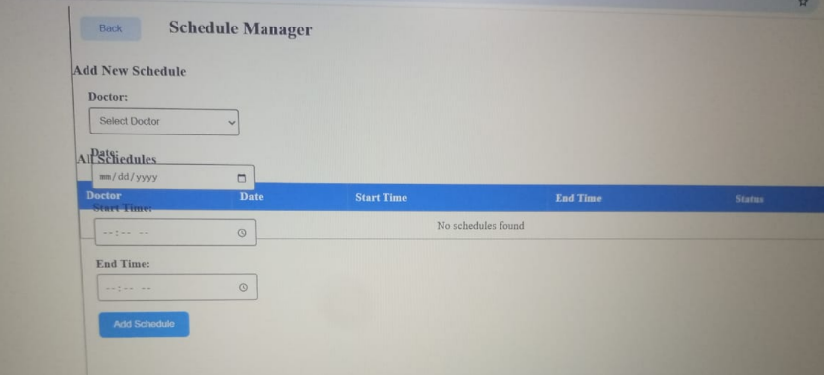
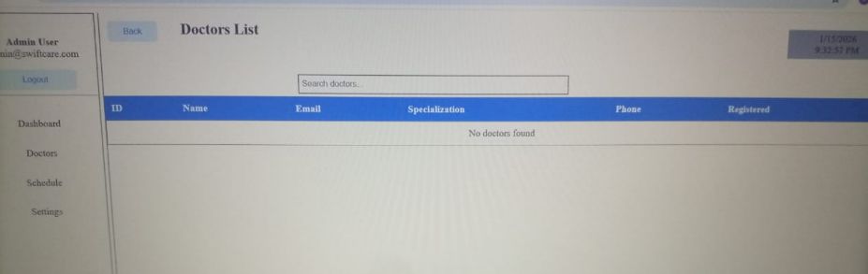
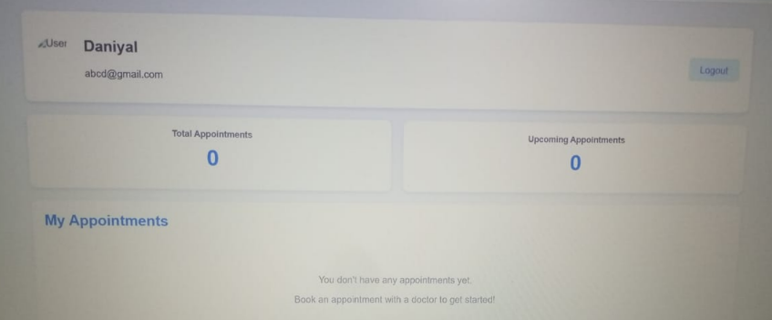
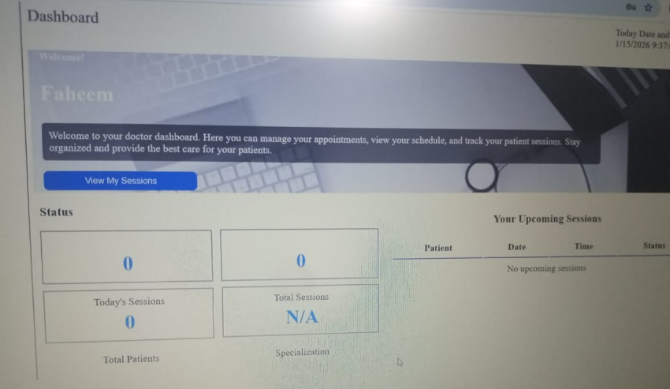
- . Conclusion
Learning Outcomes
This project helped in understanding PHP and MySQL integration, implementing CRUD operations, designing databases, and developing a real-world web application. It improved practical skills in Web Engineering and backend development.
Challenges Faced
- Database connection issues
- Managing role-based access
- Handling form validation
- Structuring code properly

